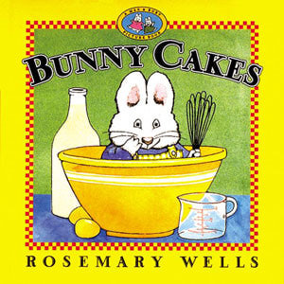 Video Reading: https://www.youtube.com/watch?v=NlO-9sufGOs
It’s grandmother’s birthday and Max is determined to make her the best earthworm cake. Ruby, however, wants to make her a surprise Angel cake with raspberry fluff icing. Max tries to help, but ends up making things a little more difficult. After making several trips to the grocery, will Max ever get the “Red Hot Marshmallow Squirters” to top of his earthworm cake. This book is a great tool to teach patience, creativity, and determination.

Bunny Cakes
By: Rosemary Wells

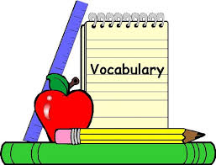
LET’S BEGIN: Set aside about 15 – 20 minutes of time to read the story, this can be before/after dinner or before/after nightly hygiene routine. After reading the book use some of the sample guided reading questions below to facilitate a discussion between you and your child concerning key factors in the book. Use this time to connect situations in the book to situations that occur in the daily routine at home, such as rules in the kitchen, helping adults cook meals, taking responsibility, etc.
Story Time Guided Reading Sample Questions
1. Why do you think Ruby put up the yellow line in the kitchen?
2. Why do you think she didn’t allow Max in the house?
3. Do you think she was trying to be mean to Max?
4. Why did Max keep going back and forth to the store?
5. If you make a mess/spill what should you do in that situation?
Activity Time: Feelings Charades
Supplies:
1. Vocabulary book from school
2. List of vocabulary words
3. Small container
Preparation:
Cut up the list of words into strips of paper, fold them, and place them in a small container
Activity Goals: Increase ability to connect nonverbal communication with knowledge of emotions/ feelings, increase understanding and application of emotions/feelings, and increase awareness of emotions/feelings are portrayed.
Participants: Entire Family
Activity Description: For this activity, family members would take turns acting the feelings words without using words our sounds, only gestures and actions. The other family members have to guess what emotion in being portrayed. After acting out a word, the person has to use the sentence starter “I feel _____ when ____”, to describe situation in which that emotion is appropriate.
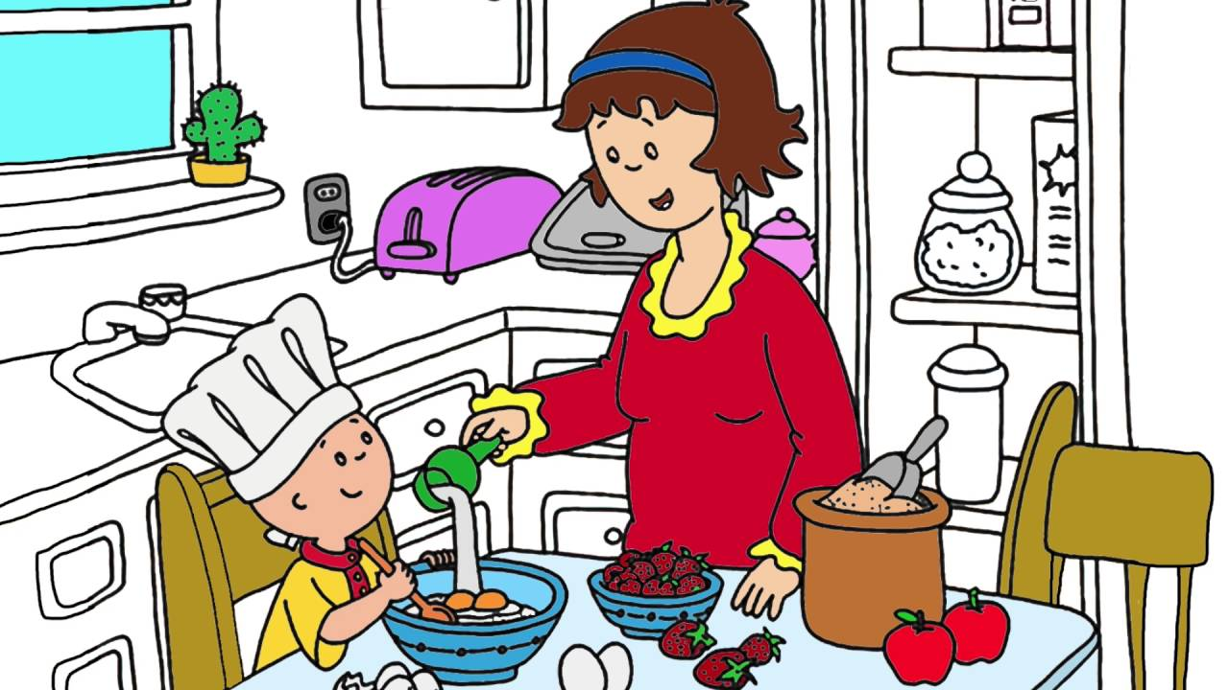
Chew & Chat – Collaborative Activity & Active Listening
Supplies:
1. Ingredients for cake (follow any cake recipe)
2. Cake Pan
3. Oven
4. Measuring Cups
Preparation Work: Shop for necessary supplies
Activity Goals: Try to use teamwork
Participants: Parent/Guardians - Children
Activity Description: One evening or early afternoon, set aside time to bake, frost, and decorate a cake with your child. During this activity, it’s important to foster teamwork. Allow the child to take some leadership, but also step in to assist when needed to create a safe environment. The goal is to provide an “alternative” story to Max and Ruby’s situation. As you all prepare the cake, it’s likely there will be accidents or spills, take time to reaffirm your child and build their self-esteem. When it’s time to frost the cake, allow the child to take the lead and encourage creativity and individuality. Focus more allowing the child to be a leader than the cake being “perfect”. After you’ve baked, frosted, and decorated the cake, cut a slice for yourself and your child and discuss what the process was like. Use the following questions to facilitate the conversation. Be sure to incorporate the vocabulary words.
1. What was your favorite part of baking the cake?
2. What was the hardest part?
3. How did you feel after you were able to complete the hard part?
4. How did you feel after completing your favorite part?
5. How did you feel when you finished everything?
6. Describe what you’re feeling right now as we take time to sit together and eat the cake.

