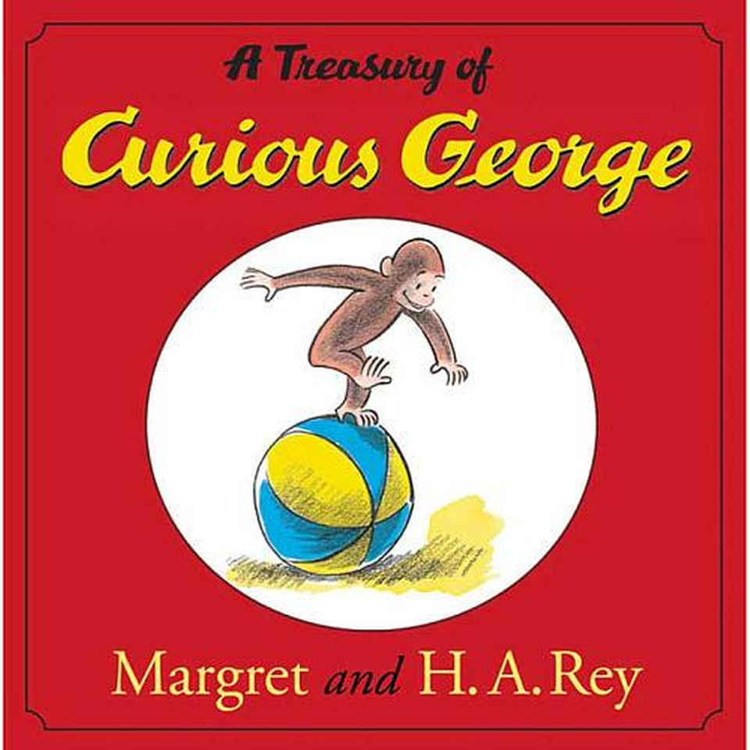
Curious George
by Margret and H.A. Rey
Parent Curriculum
Curious George is a little monkey with an insatiable curiosity. Like George, children are intrigued by new things. They are natural explores and scientists, and are anxious to know how things work. Use this book as a catalyst to boost students’ natural curiosity to learn through safe exploration. The students will learn a wild range of emotions as they explore the depth of their curiosity like Curious George.
Video of Original Curious George book read on YouTube: https://www.youtube.com/watch?v=N4vqfyjFMnA
Before you read the book with your child make sure you both talk about:
- How this book will increase your child’s comprehension skills and will tie to school and home activities.
- FEELINGS…. You want your child to understand what feelings and how they can feel a wide range of emotions as they explore the depths of their curiosities (which every child does in different ways.)

LET’S BEGIN!
Start your evening by asking what your child learned in school that day.
Read Curious George to your child. After reading the book, discuss what behaviors go with some feelings and emotions (crying=sad, hiding face=shame).
Explain that we all act differently when we have an emotion or feeling, and there is no right or wrong way to respond. However, also talk about how it is never okay to hurt ourselves or anyone else regardless of what emotions we are feeling at the time.
Give your child examples of how you respond when you are happy, sad, and mad.
Discuss times where you didn’t respond so well and have your child tell you a more appropriate way you could have responded. For example, if you are driving and another driver pulled out in front of you and you said some mean words, was that the best way to respond? Have your child give you examples of how they respond when they are happy, sad, and mad.

Feelings Chart: 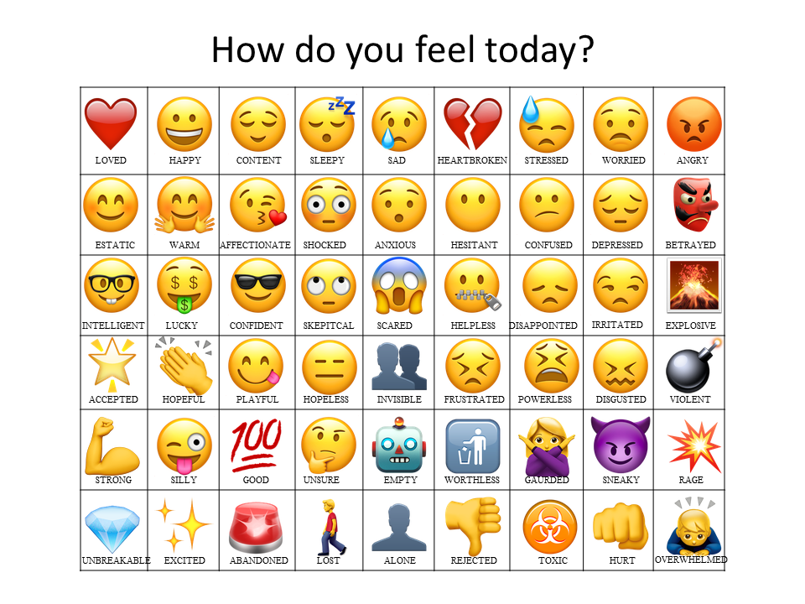
Listening Activity (parent/child time):
Take a few minutes each night to check in with your child about how they are feeling. Ask them about their day and what happened. Encourage them to give details. Help them talk about the difficult situations that come up and work through better ways to handle them. If they handled a problematic situation well then praise them for what they did well. Help them understand that everyone faces hard times in life but our responses can affect the outcome of the situation. If the child does not want to talk have him/her draw a picture and discuss what they drew with you.
Family Time:
Use your family time to play a new game. Play charades using the feeling list above (and feel free to research more feeling words). Have each family member pick a word from the list and show a behavior that explains the feeling word. The family member that guesses the correct emotion will receive a point. Whoever has the most points at the end of the game wins. This activity is good for improving communication and teamwork. It will also help your child learn to read the emotions of others. For example, if a parent picked heartbroken from the list they would act how different situations of being heartbroken for the family to guess.
Final Activity:
Keep a calendar and mark each day what feeling your child has each day. At the end your child will be able to see how different emotions are normal and make each of us different.

