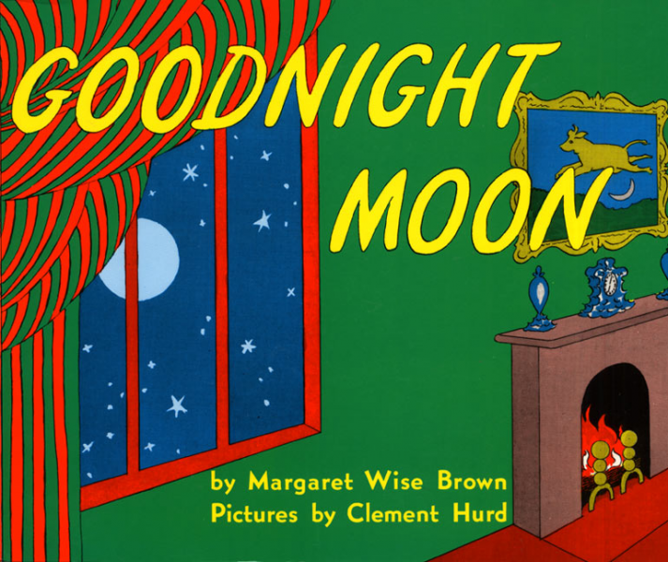
Goodnight Moon
By Margaret Wise Brown

Goodnight Moon takes place one wintery night in a rabbit’s bedroom as he completes his bedtime routine of naming and saying, “goodnight” to all items within sight. Goodnight Moon can be used to set a bedtime routine, help children feel safe, and as a fun activitiy- especially for children who struggle with bedtime! Video: https://www.youtube.com/watch?v=9yu_g5x3ZoQ
Tips for Reading:
- Reading this book will help connect and enhance your child’s learning at school and assist with bedtime routines at home.
- Use a calm, soft tone.
- Ask your child what helps them sleep.
- Discuss why sleep and routines are important.
- Ask your child to find items in their room that are found in the book.
- After reading the book, allow your child to say “goodnight” to items and people of their choice.

LET’S BEGIN: Pick a set time or range, to begin story time, for example 7:30-7:45pm. After your child is in bed, sit on the edge of the bed, on a chair, or lie down next to them— whichever is more natural. Use a soft voice to represent bedtime as a quiet, calm time and discuss using our “bedtime voices” while interacting during story time. You can fade to a whisper as you get towards the end of the book. Ask your child what helps them sleep and discuss these things with your child. Take turns identifying objects in their room found in the story. Do the same with colors. After you finish reading the story, take turns saying goodnight to people or objects.
Fun Activities:
Oreo Cookie Moons
Print out and the picture of the moon phases below. Talk about the different moon phases (full, crescent, half, gibbous) and help your child create the shapes of the different phases using sandwich cookies or Swiss cheese and crackers- if you want to avoid sugar close to bedtime. Next, have your child match the cookies or crackers with the moon phases printed.
Family Time:
Utilizing the moon phase sheet, go as a family outside to locate the moon. You can also choose to find the moon from a window. Take a few moments for the family to view the moon. Have your child identify what phase the moon appears to be at that time (or closest phase).
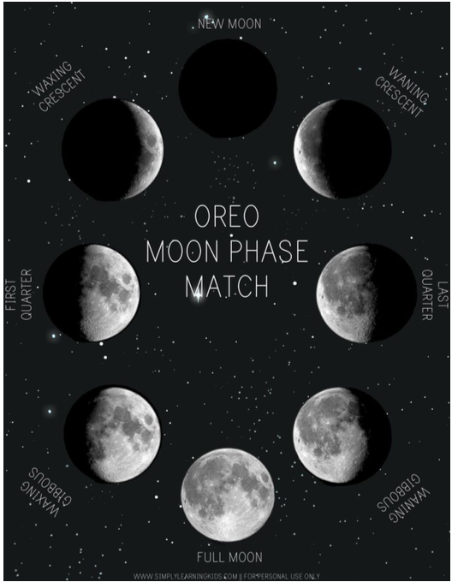
Continue with the next steps of your bedtime routine, i.e. bathing, brushing teeth, changing into pajamas, reading Goodnight Moon. Provide children with simple, clear directions to help teach their routine and give positive feedback. Also model for your child and as they learn the steps, have them show you what to do. See example below.
