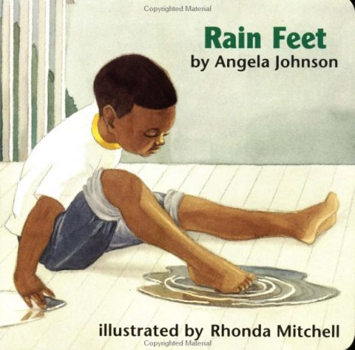
Rain Feet
By Angela Johnson

This book shows a young boy playing in the rain. The author uses beautiful pictures and colors to add emotion to the text. This book can be used to start conversations with children around emotions. Children can use this book to learn feelings through relating emotions with aspects of weather. This is a great way for parents to start talking with their children about their feelings!
Video for Reading: https://www.youtube.com/watch?v=-xvqUlGjdlM&feature=youtu.be

LET’S BEGIN: Start your evening routine by talking about what was learned in school that day. Read Rain Feet to your child. After reading the book, talk with your child about how our feelings can change just like the weather can change. Talk with your child about times they recently felt sad, happy, mad, scared, etc. Ask your child about how they responded when the felt those ways. Work with your child on identifying what types of things make them feel certain ways. For example, your child may identify they felt sad when someone took their toy and responded by crying at their desk. This allows you to help work with your child on finding better ways to respond to their feelings. Use the attached worksheet to allow your child to identify times they feel specific emotions. Use the “Cool Down Strategies” worksheet (provided on the back side) to help work with your child to identify appropriate ways to respond to those emotions.
Family Time: Use your family time to play a new game. Uno is a great family game that can incorporate talking about your feelings. Before starting the game, give each color a feeling (example: yellow- happy, red-angry, blue-sad, and green-scared). Whenever someone changes the color in the game, have everyone stop and talk about a time they felt the emotion that goes with the new color. This game allows the whole family to participate together in discussing emotions they felt. Have family members discuss how they responded when they felt that emotion.
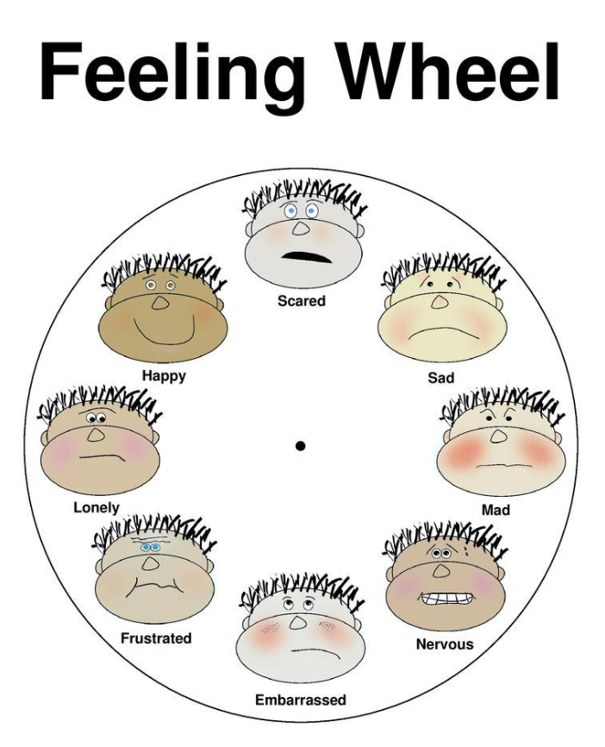
Listening Activity (parent/child time): As adults, we can often forget to take the time to listen and understand our children. One way to help establish good communication with your child is to build in routine time to check on how they are feeling. One way to do this is by using the feelings wheel (provided below) with your child each night to allow them time to talk with you about how they felt that day. It is also important for you to patriciate in the activity by talking with your child about how you felt that day and why you felt that way. This helps your child learn that you also experience many emotions like they do. This will provide you with times to talk with your child about times you responded well with your emotions and maybe times you did not respond as well. Use these examples as times for your child to discuss and talk about ways the situations could be handled better in the future.

