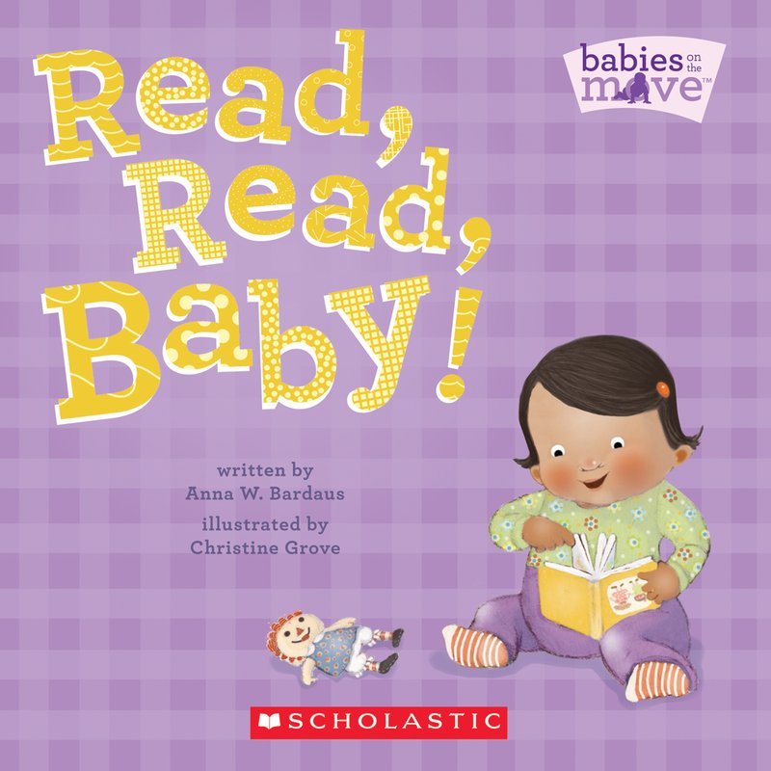
Read, Read, Baby!
By: Anna W. Bardaus
“Read, Read, Baby!” is a book that focuses on the many habits of babies on the move. This book is one of the many books that are in the babies on the move series and they show many of the curiosities that babies have as they get older, such as reading. This book is very helpful for infant growth like helping their eyes adjust to color, helping them learn basic motor skills like turning the page of a book, and introducing them to early phonics as well. Not only do older kids read, but babies can too!

LET’S BEGIN! Start off story time by talking about what the child learned in school and talk about the key points of the story. After that, start reading Read, Read, Baby! to your child. When you are done reading the book, begin talking to your child about how people have different opinions and feelings when they encounter something new (daunted, afraid, cheery, excited (feelings chart on back side)). Tell your child that we should not question our self-esteem when we have to do something that we have never done before. Explain to them that everyone has different ways of dealing with new experiences and it is normal to experience various different feelings at a time, especially when we become older. Tell your child what you felt while dealing with a new experience or a sudden change and tell them what you did. Ask your child what they did when they were faced with something new or a sudden change and how they dealt with it and who they went to for guidance. This will help your child learn to control their emotions and feelings if they know the right way to respond to certain situations.
Family Time: This time of day is very important for your child’s mental growth and character. A child will take after his/her family and they will follow what was taught to them and what was shown to them as well. Use this important part of day to talk to each family member in one whole room in front of your child about positive emotions and appropriate behavior and ask each family member what they would do and how they would feel if they had to do something new. Try to use different types of scenarios as well as real life examples in front of your child so that they learn to respect different opinions. Be completely truthful of your reaction and your family members’ reactions when talking about what they did in their experience what they could have done better. There is no perfect answer or strategy to use in any type of situation, which is why we must all practice ways to respond in certain situations.
Listening Activity (parent/child time): Many of us are very busy….work, school, home activities, etc. Spending time with your children is very important for them to learn how to give others affection and spending the right amount of time with the people in their life. In this activity, you will spend a certain amount of time to discuss with your child about any new goals that they want to set and how they are doing in school. Use this time to ask your child about events in their school day in which they thought was new to them, such as having a new student or having a new substitute teacher. Help your child set a goal or goals. Setting different types of goals every day will be very helpful in giving your child ways to improve on a certain skill or habit. Maybe the goal is brushing their teeth, cooking dinner with you, or even earning to tie their she!
