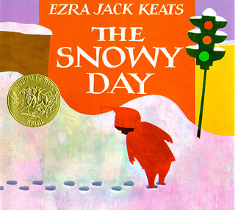
The SNOWY Day
By: Ezra Jack Keats
The setting takes place in a big snowy city in and begins in main character Peters bedroom, as he awakens too discover that snow has fallen during the night. He celebrates this day by putting on his red snow suit after breakfast and heading outside for an adventure. When he gets outside he finds snow that is piled high. Peter makes a snowman, snow angels, and pretends to be a mountain climber. As Peter discovers these innovative ways to enjoy the snow he encounters issues and learns how to deal with the changing problems that confront children as they grow up. This book can be used to describe feelings and emotions.

Video: https://youtu.be/92zPv-TsBkk
LET’S BEGIN!
Read the title of the book from the cover, while pointing to each word. Say the title together as you point to each word. Does the child know what snow is? If not, explain that snow is white and cold and it falls during the winter. If the child is familiar with snow, use the story and the pictures to start the child talking about some of his or her experiences with snow.
Reading the Book
Each time you read The Snowy Day, leave more of the "reading" or retelling to the child. Give open-ended prompts on each page. For example, ask: What is happening in this picture?
Give prompts about objects or activities in the pictures. For example, ask: What is Peter doing? (He is sliding down the hill.) Use your finger to point to what you are asking about. Evaluate the child's response. Expand it by giving more information. Ask the child to repeat the answer. If he or she needs help in answering a question, ask that question again the next time you read the book. Good words to ask about are listed in the vocabulary section below. Be sure to talk about objects and actions the child brings up, too. You may wish to discuss the prompts shown below.
Building Literacy
Start a conversation with your child about ways to play outside. What does your child like to do outside? When you are outside with your child, look for children at play. Use words like sliding, jumping, running, and throwing to describe their actions.
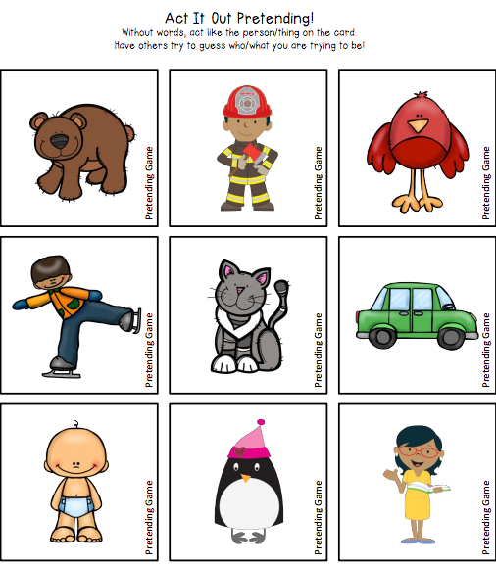
Prompts and Vocabulary Prompts
Ask the child questions after the second and third readings of The Snowy Day, to start a conversation about the book. You can prompt the child on every page, using the questions below. If the child says something spontaneously about a picture, expand on it and ask the child to repeat it. There are questions for every one or two pages of the story.
1. What does Peter see outside his window? (He sees snow.)
2. What is Peter wearing? (He is wearing his pajamas.)
3. What is Peter wearing in this picture? (He is wearing a red snowsuit.)
4. What is piled up all around outside? (Snow is piled up along the street.)
5. What is Peter making? (He is making footprints with his toes pointing out and then with his toes pointing in.)
6. Who made these lines in the snow? (Peter made these lines by dragging his feet along in the snow.)
7. Can you show me how Peter dragged his feet?
8. What is happening in these pictures? (Peter has a stick and is hitting a tree with it.)
9. What happens when Peter hits the tree with the stick? (The snow falls on his head.)
10. What's happening here? (Peter is watching big boys have a snowball fight.)
11. What does Peter make in the snow? (He makes a snowman and angels.)
12. Can you show me how to make an angel in the snow?
13. What is Peter doing in these pictures? (Peter climbs up a big mountain of snow, and then he slides down the other side.)
14. What does Peter make? (He makes a snowball.)
15. Who helps Peter take off his socks? (His mother helps him.)
16. Where is Peter? (He is in the bathtub.)
17. What is Peter looking for? Does he find it? (Peter is looking for the snowball he made, but it isn't there anymore.)
18. Do you know what happened to the snowball? (It melted in the warm house.)
19. What happens while Peter is sleeping? (It snows some more.)
20. What is happening here? (Peter and his friend are going outside to play in the snow
Act It Out Activity (Family Time)

- Print out the Act It Out Squares.
- Place squares in a non-transparent bag, so that your child cannot see what they are picking.
- One at a time, each family member should pick a card and act it out without words.
- Other family members need to guess what he/she is pretending to be.
- Take turns with this activity.

