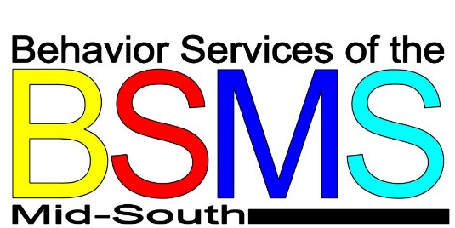
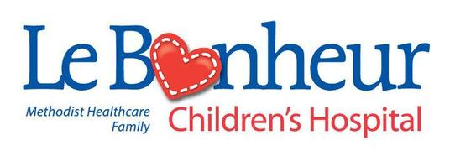

Drugs and Alcohol Fact Sheet
Adolescent abuse of drugs and alcohol is a preventable behavior, and the disease of drug/alcohol addiction is a treatable disease.
Parents are the most effective resource, and leverage point, in preventing and reducing adolescent and young adult drug and alcohol abuse and addiction.
  - 11 million American adolescents and young adults ages 12-29 need help with drug and alcohol problems; 9 million of these are between the ages of 12-25. (2009 National Study on Drugs and Health)
  - 90% of the nearly 2 million adolescents who need help with drug and alcohol problems are not getting the help they need. (2008 National Study on Drugs and Health)
  - The related public health, social services, public safety, and lost productivity costs of drug and alcohol abuse to society is $465 billion a year. ($280 billion drugs, $185 billion alcohol; Harwood 2004, 2000)
  - Parents consider drugs and alcohol as one of the most important issues facing teens, young adults, and parents today. (Horowitz Associates 2010)
  - Kids who learn a lot about the risks of drugs from their parents are up to 50% less likely to use drugs, yet only 37% report getting that benefit. (Partnership Attitude Tracking Study 2008)
  - Parents who intervene early with their child s drug or alcohol use can help significantly reduce the likelihood that they will become addicted, or suffer long-term negative consequences. (Dennis 2008)
  - 90% of all adults with drug or alcohol problems started using before the age of 18, and half before 15. (Dennis 2007)
  - There is a clear association between adolescent drug and alcohol use and unhealthy, risky behavior, including: unprotected, unplanned, unwanted sexual activity; impaired motor vehicle driving/passenger; involvement with juvenile justice system; poor academic performance and dropping out. (numerous sources)
  - Some adolescents and young adults have special vulnerability to drug and alcohol problems, including: drug or alcohol use at an early age; family history of drug or alcohol problems; existing mental health problems; having friends who use drugs and alcohol. (National Institute on Drug Abuse, Substance Abuse Mental Health Services Administration)
  - African American adolescents have consistently shown lower drug and alcohol usage rates than Caucasian adolescents. (Johnson/Monitoring the Future 2008)
  - Coerced (non voluntary) treatment for adolescent drug and alcohol problems can be just as effective as treatment after hitting bottom. (National Institute on Drug Abuse, Substance Abuse Mental Health Services Administration)
  - The adolescent brain is not fully developed until ages 22-24, and can be more vulnerable to the effects of drugs and alcohol; the part of the brain to develop last is the prefrontal cortex, responsible for decision making and moderating social behavior. (Winters 2008)
  - Effective treatment for adolescent drug and alcohol problems has been shown to be different than treatment for adults. (National Institute on Drug Abuse)
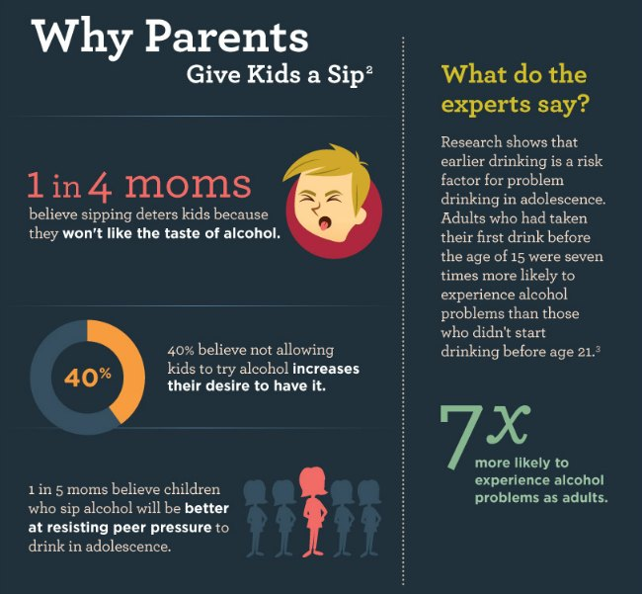
  - On an average day, 7,540 adolescents 12-17 drank alcohol for the first time, 4,365 used an illicit drug, 2,466 abused a prescription pain medication (without a prescription) and 263 were admitted to treatment for marijuana dependence, more than any other drug. (2008 OAS/ SAMHSA)

