Eating and Feeding Habits for Children

Meal times and feeding can be stressful times for many parents. Knowing what to feed your children, how much they should eat, and getting them to eat healthy foods can sometimes be challenging. However, with the right techniques and tips, meals and feeding time can become a positive and fun experience for parents and children. KidsHealth.org provides some helpful tips for engaging children from toddlers to teenager in meal times:

1. Have regular family meals.
2. Serve a variety of healthy foods and snacks.
3. Be a role model by eating healthy yourself.
4. Avoid battles over food.
5. Involve kids in the process.

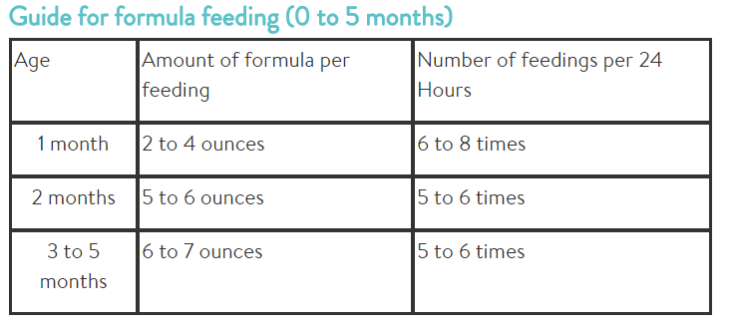
Infant Feeding
“Appropriate and healthy feeding of your baby during the first year of life is extremely important. More growth occurs during the first year than at any other time in your child's life. For the first few months, breast milk or formula is all that's needed. As your baby grows, starting a variety of healthy foods at the proper time is important for proper growth and development. And, starting good eating habits at this early stage will help set healthy eating patterns for life.” – Stanford Children’s Health
Stanford Health advices that children 4 months and under should not be fed solid foods unless advised by a physician. Breastmilk or formula are all that infants need to grow and develop healthily. Stanford Health states:
- Breast milk or formula provides your baby all the nutrients that are needed to grow.
- Your baby isn't physically developed enough to eat solid food from a spoon.
- Feeding your baby solid food too early may lead to overfeeding and being overweight.
- As a general rule, solid foods don't help babies sleep through the night.
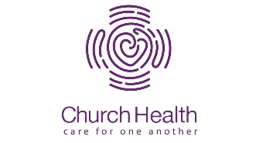
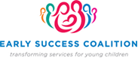
Healthy Eating and Feeding for Toddlers and Young Children
Promoting healthy eating habits for toddlers and young children, even throughout adolescence, can seem like a big tasks when there are so many unhealthy options out there that children may want. KidsHealth.org provides some simple and helpful guidelines on establishing healthy habits and choices that can be used with young children through adolescence:
- Work fruits and vegetables into the daily routine, aiming for the goal of at least five servings a day. Be sure you serve fruit or vegetables at every meal.
- Make it easy for kids to choose healthy snacks by keeping fruits and vegetables on hand and ready to eat. Other good snacks include low-fat yogurt, peanut butter and celery, or whole-grain crackers and cheese.
- Serve lean meats and other good sources of protein, such as fish, eggs, beans, and nuts.
- Choose whole-grain breads and cereals so kids get more fiber.
- Limit fat intake by avoiding fried foods and choosing healthier cooking methods, such as broiling, grilling, roasting, and steaming. Choose low-fat or nonfat dairy products.
- Limit fast food and low-nutrient snacks, such as chips and candy. But don't completely ban favorite snacks from your home. Instead, make them "once-in-a-while" foods, so kids don't feel deprived.
- Limit sugary drinks, such as soda and fruit-flavored drinks. Serve water and low-fat milk instead.

How Parents Can Model Positive Eating Behaviors
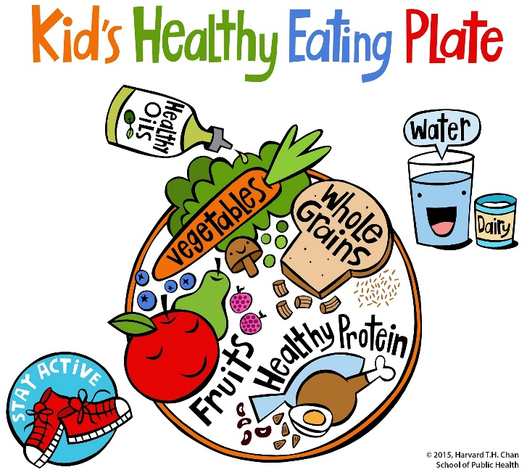
Parents can be huge role models for their children in many aspects, but especially when it comes to the food choices they make. It is important for parents to educate their children on making healthy choices while also making food a positive experience. KidsHealth.org talks about how parents should help their children understand not overeating when full and also to make appropriate portion controlled meals. It’s also important for parents to be careful about how they talk about food and their bodies, especially when it comes to dieting. Children should learn how to eat healthy and make good choices without feeling guilty about eating or how their bodies look. It’s important for parents to help foster a positive relationship between their children and food so that children do not develop negative views of food and eating.

