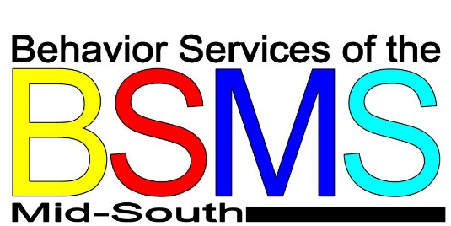

Eating Disorder Fact Sheet
EATING DISORDERS are characterized by extreme disturbances of eating behaviors such as eating too much, eating too little, or extreme distress about body weight or shape.
There are THREE types of EATING DISORDERS: Anorexia Nervosa, Bulimia Nervosa, and Binge-Eating Disorder.
EATING DISORDERS affect both females and males.
EATING DISORDERS affect all areas of a child or youth’s life (ex. home, work, school, and social life) and can lead to serious medical problems.

CLINICAL SYMPTOMS
Refusal to maintain healthy weight ---->

Bingeing ---------------------------------->

Purging ----------------------------------->

Fear of gaining weight------------------>

WHAT DOES A PARENT/CAREGIVER SEE?
Excessive dieting; skipping meals; lying about eating; refusal to maintain medically recommended weight guidelines; feeling cold a lot; becoming frail or emaciated; showing low energy (lethargy); developing brittle hair and nails
Eating unusually large quantities of food at one time; frequency eating until uncomfortably full; hiding large quantities of food or food wrappers
Regularly buying laxatives; diuretics and/or enemas; exercising excessively; excusing self to go to bathroom immediately after eating; chronically sore throat
Becoming obsessed with food, calories and/or weight control; weighing self frequently; only eating certain foods; avoiding foods they are not allergic to

Negative view of body weight or shape->

Amenorrhea (for Anorexia) ------------->

and previously enjoyed; eating only diet or low-fat foods; avoiding social activities that involve food
Complaining of feeling fat; reporting being intensely unhappy with body size or shape; youth’s view of self is highly influenced by body shape or size
Girls who have had periods do not have them anymore

