The ABC’s of Potty Training
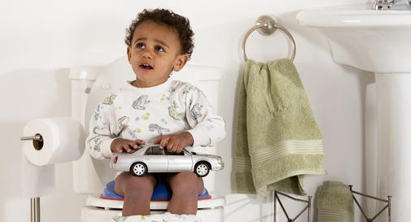
Most parents eagerly anticipate toilet training as a milestone in their child's development – if for no other reason than that it means an end to changing diapers. But few moms and dads are prepared for how long toilet training can take.
Sure, some kids master it within a few days, but others take several months or longer. You and your child have a better chance of success if you understand the important elements of training before you start. Here are the basic steps:

A. Assess your child's readiness – and your own
When children are about a year old, they can begin to recognize that they have a full rectum or bladder. Some are ready to start potty training as early as 18 months, while others aren't interested until after age 3. Many parents begin potty training when their children are about 2 1/2.

B. Buy the right equipment
First and foremost, invest in a child-size potty chair or a special adapter seat that attaches to your regular toilet. This can make children feel less anxious about using the grown-up toilet – some fear falling into it, while others dislike the loud noise of the flush.

C. Create a routine
Set your child on the potty seat, fully clothed, once a day – after breakfast, before her bath, or whenever else she's likely to have a bowel movement. This helps her get used to the potty and accept it as part of her routine. If there's not a bathroom nearby, bring your child's portable potty outside, to the playroom, or wherever she usually is. Once she's fine with this routine, have her sit on the potty bare-bottomed. Again, let her get used to how this feels. At this point, let her know that pulling down your pants before using the potty is a grown-up thing to do, and that this is what Mommy and Daddy (and any older siblings) do every day.

D. Demonstrate for your child
Children learn by imitation, and watching you use the bathroom is a natural way to understand what using the toilet is all about.

E. Explain the process
Show your child the connection between pooping and the toilet. The next time she poops in her diaper, take her to the potty, sit her down, and empty the diaper into the bowl. If she wants to, let her flush so she can watch her feces disappear. (Don't force her if she's scared.)

F. Foster the habit
Encourage your child to sit on the potty whenever he feels the urge to go. If he needs help getting there and taking off his diaper, make sure he knows it's okay to ask you any time.

G. Grab some training pants
Once training is under way, consider adding training pants to your routine. Training pants are disposable or cloth diapers that pull on and off like underwear. They enable your child to undress for the potty on her own, which is a critical step toward becoming completely potty trained.

H. Handle setbacks gracefully
Toilet training can be difficult for parents and children. Keep in mind that temporary setbacks are completely normal, and virtually every child will have several accidents before being able to stay dry all day long. An accident doesn't mean that you've failed. When it happens, don't get angry or punish your child. After all, it's only recently that his muscle development has allowed him to hold his bladder and rectum closed at all, and he's still learning why it's important to use the potty. Mastering the process will take time.

I. Introduce night training
Don't give away that stash of diapers just yet. Even when your child is consistently clean and dry all day, it may take several more months, or even years, for her to stay dry all night. At this age, her body is still too immature to wake her up in the middle of the night reliably just to go to the bathroom. It's normal for kids to continue wetting the bed well into grade school.

J. Jump for joy – you're done!
Believe it or not, when your child is mentally and physically ready to learn this new skill, he will. And if you wait until he's really ready to start, the process shouldn't be too painful for either of you. When it's over, reinforce his pride in his achievement by letting him give away leftover diapers to a family with younger kids, or help you pack up the cloth diapers and send them away with the diaper delivery service one last time. And don't forget to pat yourself on the back. Now you won't have to think about diapers ever again – for this child, anyway!

