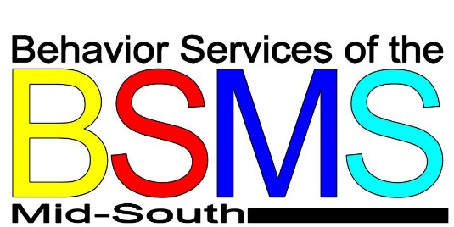

Speech and Language Development
“The first 3 years of life, when the brain is developing and maturing, is the most intensive period for acquiring speech and language skills. These skills develop best in a world that is rich with sounds, sights, and consistent exposure to the speech and language of others. There appear to be critical periods for speech and language development in infants and young children when the brain is best able to absorb language. If these critical periods are allowed to pass without exposure to language, it will be more difficult to learn.” -National Institute on Deafness and Other Communication Disorders (NIDOCD)
Speech and language development in children can be measured in important milestones that children should reach by certain ages. It important for parents to know what ages their children should reach certain milestones by to be able to tell if your child may have a language or speech development problems. Below are milestones children infant through six years old provided by Language Disorders (LD) Online:
Birth to 1 Year Old:
- Recognizes name
- Says 2-3 words besides "mama" and "dada"
- Imitates familiar words
- Understands simple instructions
- Recognizes words as symbols for objects: Car - points to garage, cat – meows

Between Age 1 – 2 yrs. Old:
- Understands "no"
- Uses 10 to 20 words, including names
- Combines two words such as "daddy bye-bye"
- Waves good-bye and plays pat-a-cake
- Makes the "sounds" of familiar animals
- Gives a toy when asked
- Uses words such as "more" to make wants known
- Points to his or her toes, eyes, and nose
- Brings object from another room when asked

Between Age 2 – 3 yrs. Old:
- Identifies body parts
- Carries on 'conversation' with self and dolls
- Asks "what's that?" And "where's my?"
- Uses 2-word negative phrases such as "no want".
- Forms some
- plurals by adding "s"; book, books
- Has a 450 word vocabulary
- Gives first name, holds up fingers to tell age
- Combines nouns and verbs "mommy go"
- Understands simple time concepts: "last night", "tomorrow"
- Refers to self as "me" rather than by name
- Tries to get adult attention: "watch me"
- Likes to hear same story repeated
- May say "no" when means "yes"
- Talks to other children as well as adults
- Solves problems by talking instead of hitting or crying
- Answers "where" questions
- Names common pictures and things
- Uses short sentences like "me want more" or "me want cookie"
- Matches 3-4 colors, knows big and little

Between Age 3 – 4 yrs. Old:
- Can tell a story
- Has a sentence length of 4-5 words
- Has a vocabulary of nearly 1000 words
- Names at least one color
- Understands "yesterday," "summer", "lunchtime", "tonight", "little-big"
- Begins to obey requests like "put the block under the chair"
- Knows his or her last name, name of street on which he/she lives and several nursery rhymes

Between Age 4 – 5 yrs. Old:
- Has sentence length of 4-5 words
- Uses past tense correctly
- Has a vocabulary of nearly 1500 words
- Points to colors red, blue, yellow and green
- Identifies triangles, circles and squares
- Understands "In the morning" , "next", "noontime"
- Can speak of imaginary conditions such as "I hope"
- Asks many questions, asks "who?" And "why?"

Between Age 5 – 6 yrs. Old:
- Has a sentence length of 5-6 words
- Has a vocabulary of around 2000 words
- Defines objects by their use (you eat with a fork) and can tell what objects are made of
- Knows spatial relations like "on top", "behind", "far" and "near"
- Knows her address
- Identifies a penny, nickel and dime
- Knows common opposites like "big/little"
- Understands "same" and "different"
- Counts ten objects
- Asks questions for information
- Distinguished left and right hand in herself
- Uses all types of sentences, for example "let's go to the store after we eat

