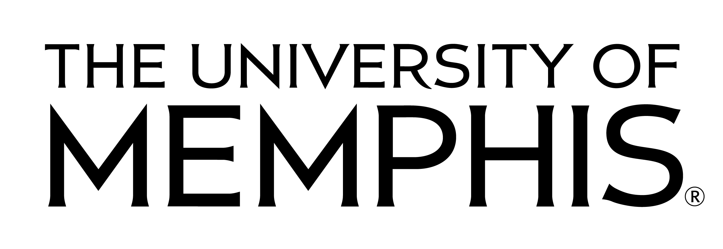
Department of Foreign Languages and Literatures
25th Annual Language Fair
Saturday, April 2, 2016
Payment Form — 2016 Language Fair

Please complete and mail this form to the Bursar’s Office with a check, postmarked no later than February 28, 2016.
• You should send one payment form per language, per school. For example, if there are three Spanish teachers at your school, one form should be submitted for Spanish.
• If you personally teach more than one language, you should provide information on two separate forms.

LANGUAGE: ______________________________________________________
SCHOOL: ______________________________________________________
TEACHER(S): ______________________________________________________
EMAIL(S): ______________________________________________________
PHONE NO.: ______________________________________________________
NUMBER OF STUDENTS REGISTERED FOR THE EVENT ________________

TOTAL — PARTICIPANT ENTRY FEES [$8.00 per student]: ________________
FEES. Students attending the Fair are required to pay a non-refundable fee of $8.00.
• Each student pays the fee only once, even if entered in more than one event, or for more than one language.
• Please make payment by check only, sending one check for the total amount.
• The check should be made out payable to The University of Memphis.
• NOTE: The Registration Form and Participant Entry Sheet must be sent in separately; see those sheets for details.

Please send this completed Payment Form and total payment by mail to:
Bursar’s Office
The University of Memphis
PO Box 1000, Department 313
Memphis, TN 38148-0313
Bursar’s Use Only
Detail Code: MOSJ
Cashier _______________________ Receipt # _______________ Date _______________

