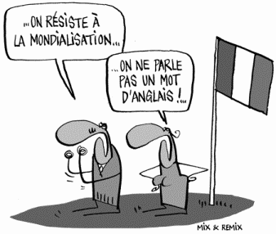Tutoring for French

**Department of World Languages and Literatures**

**Free tutoring hours.**

**Spring 2020.** No appointment necessary, just show up!

Monday

09:00 – 12:00 Jones 253 e Bibata Abdoulaye-L.

11:00 – 14:00 Jones 253 e Katelynn Baker

Tuesday

09:00 – 12:00 Jones 253 e Bibata Abdoulaye-L.

09:00 – 12:00 Jones 253 e Katelynn Baker

Wednesday

09:00 – 12:00 Jones 253 e Bibata Abdoulaye-L.

11:00 – 14:00 Jones 253 e Katelynn Baker

Thursday

09:00 – 11:00 Jones 253 e Bibata Abdoulaye-L.

09:00 – 12:00 Jones 253 e Katelynn Baker

Friday

By Appointment Jones 253 e Katelynn Baker