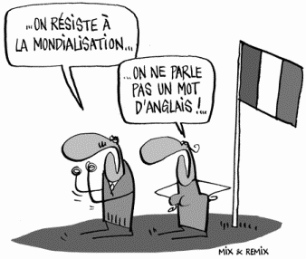
Tutoring for French
Department of World Languages and Literatures
Free tutoring hours.
Spring 2020. No appointment necessary, just show up!

Monday
09:00 – 12:00 Jones 253 e Bibata Abdoulaye-L.
11:00 – 14:00 Jones 253 e Katelynn Baker

Tuesday
09:00 – 12:00 Jones 253 e Bibata Abdoulaye-L.
09:00 – 12:00 Jones 253 e Katelynn Baker


Wednesday
09:00 – 12:00 Jones 253 e Bibata Abdoulaye-L.
11:00 – 14:00 Jones 253 e Katelynn Baker

Thursday
09:00 – 11:00 Jones 253 e Bibata Abdoulaye-L.
09:00 – 12:00 Jones 253 e Katelynn Baker

Friday
By Appointment Jones 253 e Katelynn Baker

